Construction Site Best Management Practices
Checklist for Stormwater Compliance

A Stormwater Guide for Construction Sites Patterned after the Oklahoma Department of Environmental Quality’s Site Inspection Report

February 2019

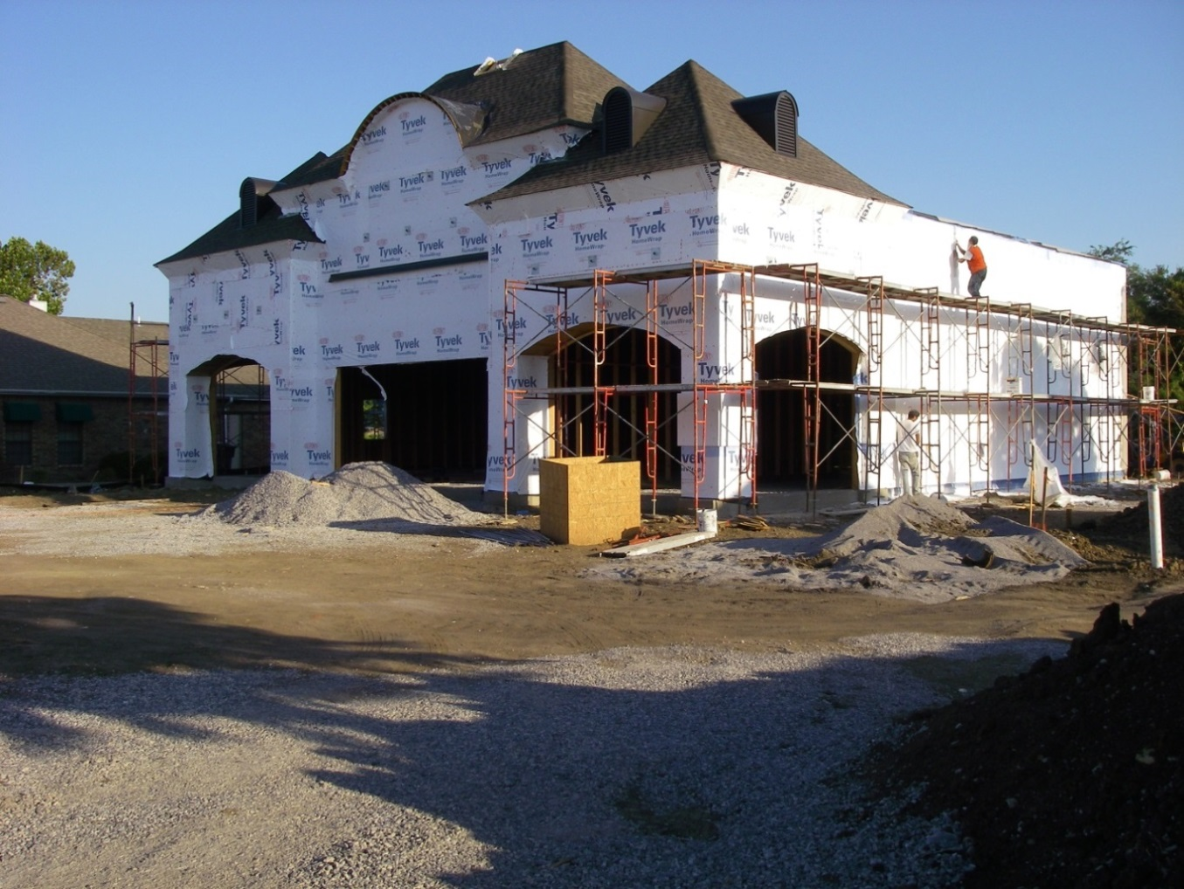

INCOG
2 West Second Street
Suite 800
Tulsa, OK 74103

This guide was developed to assist developers, builders and construction site personnel understand stormwater requirements and formatted to be used as an inspection sheet to monitor compliance. Specific requirements vary according to state, county and municipal regulations, so check state and local regulations before construction activity begins. As a result, the best management practices (BMPs) mentioned here will be generally accepted as good practice in most localities. This should be considered a living document that is updated as conditions and requirements change and customized to meet local needs.
This inspection form is patterned after the State of Oklahoma’s OKR10 permit requirements and Site Inspection Report with additional information added where appropriate. Where detailed information is included, refer to your permit or regulatory agency to ensure it is pertinent to your situation. Information from the Oklahoma Department of Environmental Quality is in black. Inclusion of suggested information is noted in blue.

A Stormwater Guide for Construction Site Inspections
General Information (OKR10 Part 4.3.13.E)
Name of Project: |  |  | DEQ Permit No:
Inspector Name: |  | Inspector Title:
Inspector Contact Information: |  |  |  | Inspection date:
Inspection Frequency: | Every 7 days and within 24 hours of a 0.50” rain, or discharge from snowmelt
 | Every 14 days and within 24 hours of a 0.50” rain or discharge from snowmelt
 | Once per month (for stabilized areas)
Describe present phase of construction:
Type of inspection: Regular Pre-storm event During storm event Post-storm event
Weather at the time of the inspection:
Was this inspection after a 0.50” storm event? Yes No If yes, amount:
Total rainfall that triggered the inspection in inches:
Are there any discharges at the time of the inspection? Yes No

List all areas where soil stabilization is required to begin because construction work in that area has permanently or temporarily stopped and all areas where stabilization has been implemented:
Stabilization of Exposed Soil (OKR10 Part 4.3.13.D)
Stabilization Area | Stabilization Method | Have you Initiated Stabilization? | Observations
 |  | Yes No If yes, date:
 |  | Yes No If yes, date:
 |  | Yes No If yes, date:
 |  | Yes No If yes, date:
 |  | Yes No If yes, date:
Are all slopes and disturbed areas not actively being worked properly stabilized? Yes No

Additional observations and notes: ___________________________________________________________________________________________________________________________________________________________________________________________________________________________________________________________________________________________________________________________________________________________________________________________________________________________________________________________________________________________________________________________________________________________________________________________________________________
Notes: For each area where stabilization has been initiated, describe the progress that has been made, and what additional actions are necessary to complete stabilization. Note the effectiveness of stabilization in preventing erosion. If stabilization has been initiated, but not completed, make a note of the date it is to be completed. If stabilization has been completed, make a note of the date it was completed. If stabilization has not yet been initiated, make a note of the date it is to be initiated, and the date it is to be completed.
Provide a list/description of all structural and non-structural BMPs that your Stormwater Pollution Prevention Plan (SWP3) indicates will be installed and implemented at your site. You must separately identify the location of each control. During inspection, identify whether they are installed and operating properly or any corrective action is necessary. Provide the date on which the condition that triggered the need for maintenance or corrective action was first identified. In the notes section you must describe the specifics about the problem you observed.

Condition and Effectiveness of BMP Controls & Pollution Prevention (OKR10 Part 3.3, 4 & 5)
No. | BMP Description & Location | Is BMP Installed & Operating Properly? | Corrective Action (CA) Required? | Date Maintenance or CA First Identified | Observations
1. | Silt Fence/Fiber Rolls/Berm/Wattles Location: | Yes  No | Yes  No
2. | Silt Dikes/Check Dams/Rock Dams Location: | Yes  No | Yes  No
3. | Are natural resource areas (e.g., streams, wetlands, mature trees, etc.) protected with barriers or similar BMPs? | Yes  No | Yes  No
4. | Are discharge points and receiving waters free of sediment deposits? | Yes  No | Yes  No
5. | Stabilized Construction Entrance/Exit  Location: | Yes  No | Yes  No
6. | Inlet Protection On All Storm Drains  Location: | Yes  No | Yes  No
7. | Sand Bag Barrier/Gravel Bag Barrier  Location: | Yes  No | Yes  No
8. | Vegetated Swales  Location: | Yes  No | Yes  No
9. | Compost Blankets/Geotextiles/Mats  Location: | Yes  No | Yes  No
10. | Vegetative Buffers  Location: | Yes  No | Yes  No
11. | Sediment Trap/Sediment Basin  Location: | Yes  No | Yes  No
12. | Concrete Washout Pit is clearly marked and maintained  Location: | Yes  No | Yes  No
13. | Dust Control/Prevention | Yes  No | Yes  No

Notes: The permit differentiates between conditions requiring reports and maintenance, and those requiring corrective action. The permit requires maintenance in order to keep controls in effective operating condition and requires repairs if controls are not operating as intended. Corrective actions are triggered only for specific, more serious conditions – whether a required stormwater control was never installed, or was installed incorrectly, or not installed in accordance with the requirements of OKR10.
Pollution Prevention and Waste Management (OKR10 Part 3.3.3)
Items of Inspection | Response & Reason | Actions(s) Needed
Is the site free of floatables, litter, and construction debris? | Yes No If yes, date:
Are material storage and handling areas, including fueling areas, free of spills and leaks? | Yes No If yes, date:
Are spill kits available where spills and leaks are likely to occur? | Yes No If yes, date:
Are dumpsters and waste receptacles covered when not in use? | Yes No If yes, date:
Has preventative maintenance been conducted on equipment and machinery? | Yes No If yes, date:
Are material stockpiles sufficiently contained? | Yes No If yes, date:
Has there been any sediment tracked out from the site onto the surface of paved streets, sidewalks or other paved areas outside of the site? | Yes No If yes, date:
Is the project free from visible erosion and/or sedimentation? | Yes No If yes, date:

Additional observations and notes: ___________________________________________________________________________________________________________________________________________________________________________________________________________________________________________________________________________________________________________________________________________________________________________________________________________________________________________________________________________________________________________________________________________________________________________________________________________________

Complete the following section if a discharge is occurring at the time of inspection:
Description of Discharges (OKR10) Part 4.3.13.D.2.f)
Was a stormwater discharge or other discharge occurring from any part of your site at the time of the inspection? Yes No If yes, provide the following information for each point of discharge?
Specify Discharge Location | Observations (Visual Quality of the Discharge)
1. | Describe the discharge (color, odor, floating, settled/suspended solids, foam oil sheen):  Are there any visible signs of erosion and/or sediment accumulation that can be attributed to your discharge? Yes No If yes, describe what you see, specify the location(s) where these conditions were found, and indicate whether modification, maintenance, or corrective action is needed to resolve the issue:
2. | Describe the discharge (color, odor, floating, settled/suspended solids, foam oil sheen):  Are there any visible signs of erosion and/or sediment accumulation that can be attributed to your discharge? Yes No If yes, describe what you see, specify the location(s) where these conditions were found, and indicate whether modification, maintenance, or corrective action is needed to resolve the issue:

Contractor or Subcontractor Certification and Signature:
I certify under penalty of law that this document and all attachments were prepared under my direction or supervision in accordance with a system designed to assure that qualified personnel properly gathered and evaluated the information submitted. Based on my inquiry of the person or persons who manage the system, or those persons directly responsible for gathering the information, the information submitted is, to the best of my knowledge and belief, true, accurate, and complete. I am aware that there are significant penalties for submitting false information, including the possibility of fine and imprisonment for knowing violations.
Signature: ______________________________ Date: _______________
Print Name: ____________________________ Affiliation: _______________________

